## COLLABORATE

The **Collaborate** tab displays all users who have accessed a patient’s information as well as the specific pages viewed. It provides a record of all user activity, including User Name, User Group, Address, and Phone Number when grouped by user; and Session Start Time, User Name, and User Group when grouped by session.

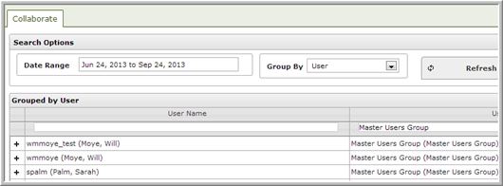

By default, the date range includes the last 3 months grouped by user. Clicking on the **Date Range** filter allows you to limit the results to any of the displayed ranges or to specify a start and end date.

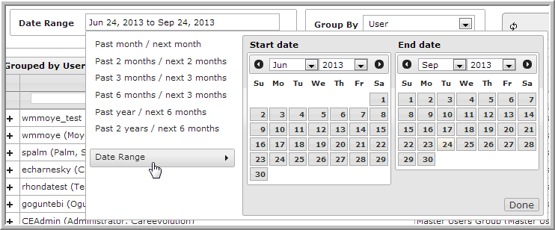

Search by user name or user group using the search boxes above the respective columns.

Note: You must enter the entire user name/group when searching.

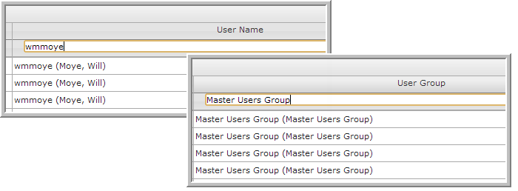

Click on the **+** sign beside the session to view a complete record of the user’s access to the patient’s record.



Click on any of the headers to sort by column.

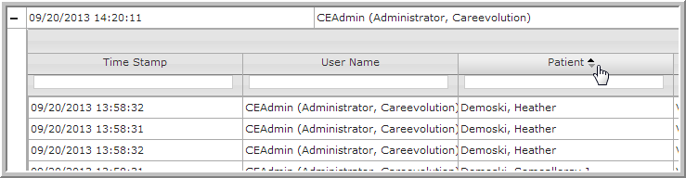

Each log event includes time stamp, user name, patient viewed, actions performed by the user, details (including page duration), and applications viewed.

